

**FALL Coloring Contest**

**Name: ­­­­­­­­_________________________________________**

**Age:**______________

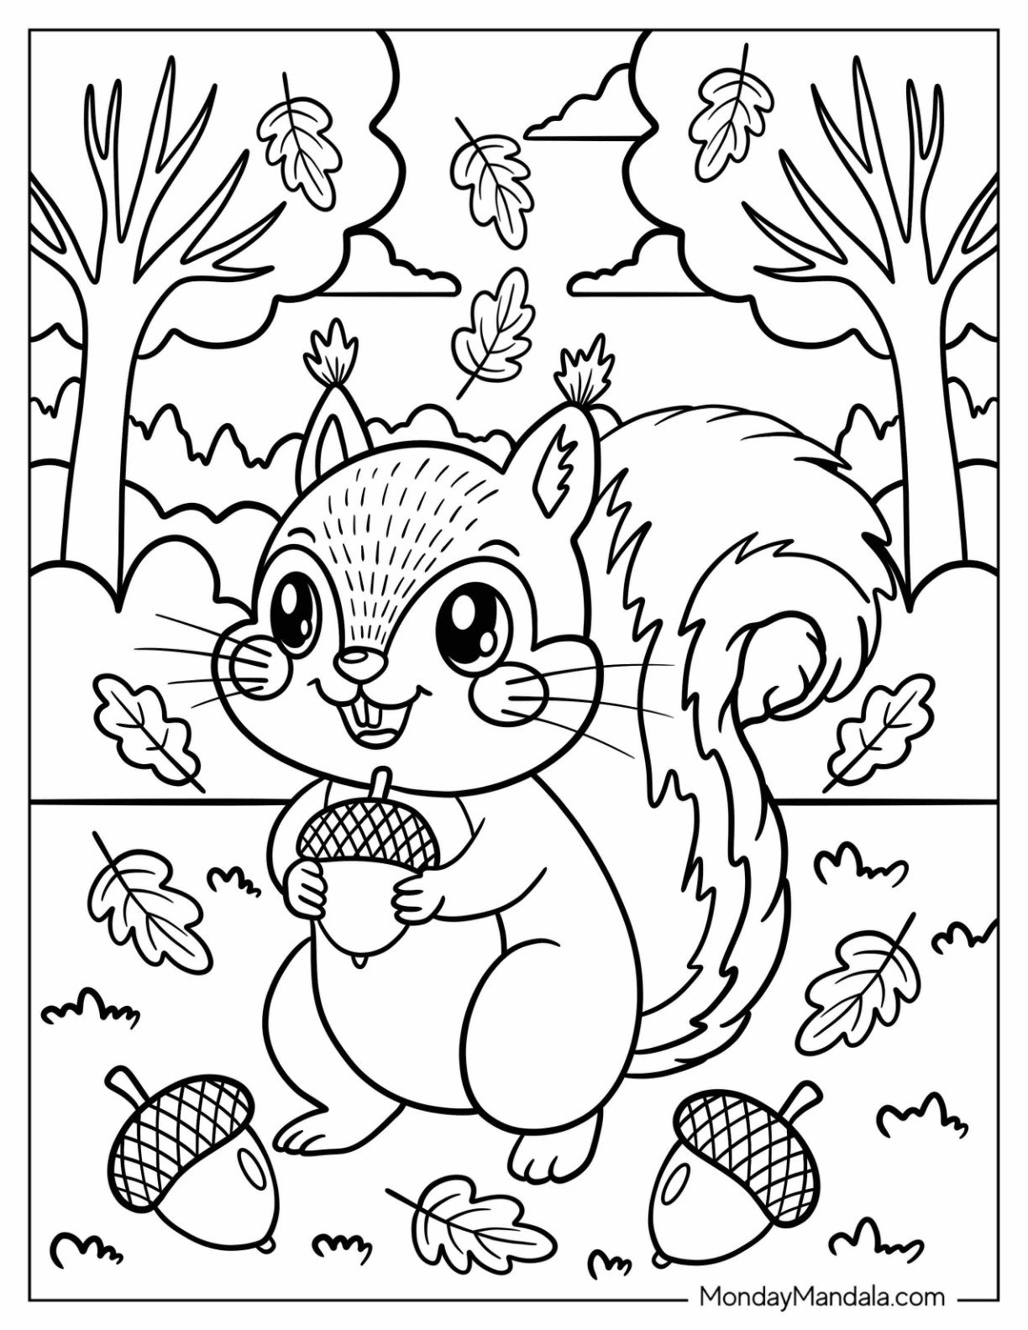

Coloring Contest Rules

Three age groups may participate. They are:

3-5 years old

6-8 years old

9-12 years old

All age groups will be judged separately. There will be a 1st and 2nd prize winner in each age group. All entries must be received by

Sunday, November 2nd by the time the store closes (8PM).

All entries will be posted in the store.

One entry per child please.

**Directions:** Please put your **name** (including last initial) and **age** on the front and a **clearly written phone number** on the back. The winners will be voted on by the employees. All winners will be notified by November 6th.

**Prizes:**

**3-5 years old**

1st - $25 gift certificate to Amazon

2nd- 2 coloring books

**6-8 years old**

1st-$25 gift certificate to Amazon

2nd -$10 Village Market gift certificate

**9-12 years old**

1st- $25 gift certificate to Amazon

2nd-$10 Village Market gift certificate

If you have any questions about the contest, please feel free to contact us at 510-547-3200 or villagemarketccl@gmail.com

**\* Must Have To Win* Phone Number:____________________________**